KLP-740Z

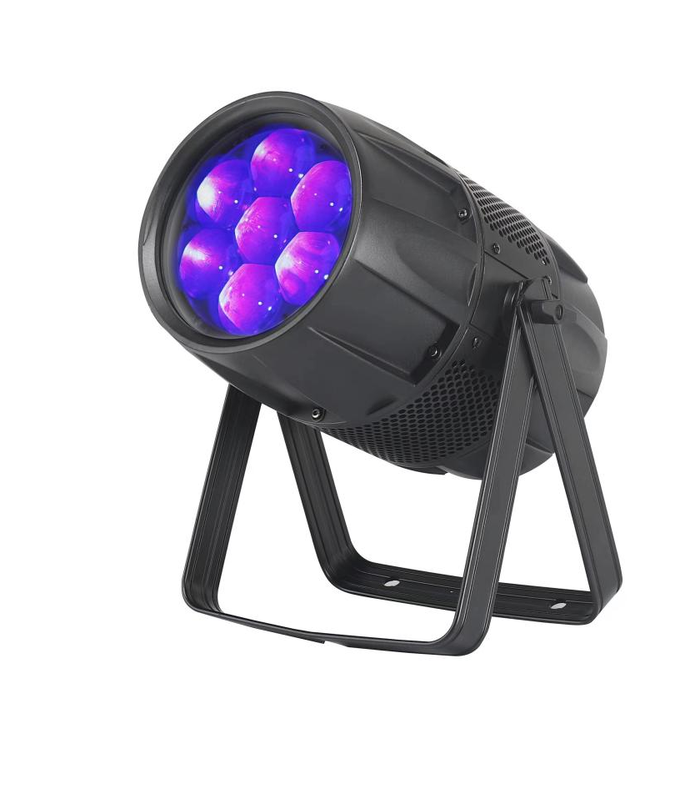

User manual

Please read this user manual before using this product



- Checking before using
No. | Item | Quantity | Unit
1 | Light | 1 | piece
2 | Power cable with blue head | 1 | piece
3 | User manual | 1 | piece
★For security reasons and in accordance with the terms, reassemble or modify the product is not allowed without permission. Please note that due to human damage caused by improper use of the product, it will break the warranty qualification. Moreover, the unprofessional operation may lead to short circuits, burns or electric shock, and so on.
★This device has been full inspection before shipping. For your safety, please operate it according the User Manual.
★If any damage caused by improper operation will result in the termination of the warranty claims. The manufacturer does not accept any responsibility of property damage due to improper operation or personal injury due to non-compliance with the operating instructions.
★Keep the manual in a safe place for future reference as well as after the product sale, lease, etc.
★Note: Based on product improvements, specification may change without notice. Changes in product specifications related rights will be reserved.
2. Safety Instruction

1. When opening the packing, take all accessories out, and remove the light to a horizontal table for good operation. First check whether the accessories are complete, then check carefully whether the whole light has no damage. If there is any damage, please contact us as soon as possible.
2. AC Power: Check whether the local power supply is accordance with the
requirements of the product rated voltage.
3. The product is only suitable for indoor working environment. The light should
keep dry, keep away from wet, overheat or dusty environment. Don't come into contact with water and other liquids to prevent or reduce the risk of electric shock or fire.
4. Please do not install the light directly on the surface of the combustible substance.
5. The people who install, operate and maintain of light professional certificate required.
6. When there are faults of the light, please stop using the light immediately. Don't try to repair, please contact the nearest authorized technical assistance center, if the parts damage, always use the same type of parts replaced.
7. Don't touch any electrical wiring in the process of operation to prevent the risk of electric shock.
8. To make sure the light working environment temperature, the highest do not exceed 40℃, the lowest do not exceed - 20 ℃.
9. Under the stable cooling working situation, the highest temperature of the housing of the light can reach 80 ℃, please do not touch.
10. The light is design according to the type of electric shock protection. The light should be use in good connection grounding power system and the earth sign port of the light should be connected to the installing fixtures.
11. Do not use the damage of the insulating layer wire and also do not use the power cord overlap on the other wire. When not in use or clean the light, please disconnect the power, don't pull the plug in hard or just drag the wires.
12. There are no components inside for maintenance. Before start operation the light, please check whether all of the shell is installed. In the case of the shell open used the light is prohibited.
Note: Before performing any installation, repair and cleaning of the lamp, please confirm that the power cable has been cut off.
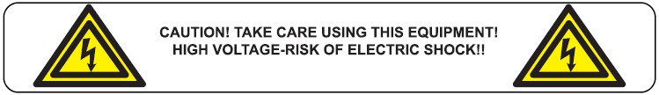

3. Product specification
1.Voltage: AC100-240V, 50-60Hz
2.Power consumption: 300W
3.Light source: 7pcs 40W RGBW 4in1 LED
4.Beam angle: 5-45 °
5.Control mode: voice control, self-propelled, DMX, master / slave.
6.Channel: 5CH,6CH,7CH,9CH,-9CH,10CH,11CH,13CH.
7.Display: TFT full color display
8.Size: 296 * 220 * 436mm
9.Net weight: 7.8kg

4. Display Main Function
Display Interface
Main Menu | MENU  DOWN  UP  ENTER | Address | 001-512 | Modify the address code
 | MENU  DOWN  UP  ENTER | Address | 000C-080C | Temperature Display
 | MENU  DOWN  UP  ENTER | Patterm | 5.6.7.9.-9.10 | Channel Mode Display
 | MENU  DOWN  UP  ENTER | Patterm | 11,13CH | Channel Mode Display
 | MENU  DOWN  UP  ENTER | Manual control | Red | 000-255 | Red Dimming
 | MENU  DOWN  UP  ENTER | Manual control | Green | 000-255 | Green Dimming
 | MENU  DOWN  UP  ENTER | Manual control | Blue | 000-255 | Blue Dimming
 | MENU  DOWN  UP  ENTER | Manual control | White | 000-255 | White Dimming
 | MENU  DOWN  UP  ENTER | Manual control | Strobe | 00HZ--20HZ | Strobe from slow to fast
 | MENU  DOWN  UP  ENTER | Manual control | Macro | S-0--S-6 | 1-6,Selection of built-in 6 program
 | MENU  DOWN  UP  ENTER | Manual control | Speed | 000-100 | Macro speed Setting
 | MENU  DOWN  UP  ENTER | Manual control | Focusing | 000-255 | Focusing manually adjusted
 | MENU  DOWN  UP  ENTER | Program | 00-50 | Speed adjustment of Auto-run adjustment
 | MENU  DOWN  UP  ENTER | Voice | 00-50 | Sensitivity adjustment of voice control program

Background Operation | In modify address ,press the "Enter"confirmation key 5 seconds to dto enter the background.  DOWN--back  UP--forward  ENTER--determine the exit | Red | 100-255 | Red current setting
 |  | Green | 100-255 | Green current setting
 |  | Blue | 100-255 | Blue current setting
 |  | White | 100-255 | White current setting
 |  | Patterm | 5.6.7,9,-9 | Channel mode Setting
 |  | Patterm | 10.11.13CH | Channel mode Setting
 |  | Reverse | NO | Macro speed Setting from fast to slow
 |  | Reverse | YES | Macro speed Setting from slow to fast
 |  | Dimming | TG-0--TG-4
 |  | Trip | 000-200 | Focusing Trip Setting
 |  | Position | 000-200 | Focusing Position Setting
 |  | Send out | NO | Set background values online
 |  | Send out | YES | YES--valid，,press the "Enter" key to send
When the temperature sensor is installed, the fan starts when the temperature is greater than or equal to 42 degrees Celsius, and stops when the temperature is less than 38 degrees Celsius.Start the intelligent constant temperature function when the temperature is greater than 65 degrees.

5. Display Function Instruction
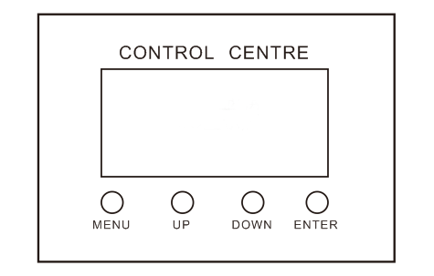

6.1,DMX 512 Channel Mode 5 Channel Mode
CH05 | Channel Function | DMX Value | Function Description
5 Channel Mode | Channel Function | DMX Value | Function Description
CH1 | focusing | 0-255 | 0 invalid,1-255 Linear adjustment
CH2 | Red | 0-255 | 0-100%W Red Dimming
CH3 | Green | 0-255 | 0-100%W Green Dimming
CH4 | Blue | 0-255 | 0-100%W Blue Dimming
CH5 | White | 0-255 | 0-100%W White Dimming

6.2,DMX 512 Channel Mode 6 Channel Mode
CH06 | Channel Function | DMX Value | Function Description
6 Channel Mode | Channel Function | DMX Value | Function Description
CH1 | focusing | 0-255 | 0 invalid,1-255 Linear adjustment
CH2 | Master Dimming | 0-255 | 0-100% Red、Green、Bluse、White Dimmming
CH3 | Red | 0-255 | 0-100%W Red Dimming
CH4 | Green | 0-255 | 0-100%W Green Dimming
CH5 | Blue | 0-255 | 0-100%W Blue Dimming
CH6 | White | 0-255 | 0-100%W White Dimming

6.3,DMX 512 Channel Mode 7 Channel Mode
CH07 | Channel Function | DMX Value | Function Description
7 Channel Mode | Channel Function | DMX Value | Function Description
CH1 | focusing | 0-255 | 0 invalid,1-255 Linear adjustment
CH2 | Master Dimming | 0-255 | 0-100% Red、Green、Bluse、White Dimmming
CH3 | Red | 0-255 | 0-100%W Red Dimming
CH4 | Green | 0-255 | 0-100%W Green Dimming
CH5 | Blue | 0-255 | 0-100%W Blue Dimming
CH6 | White | 0-255 | 0-100%W White Dimming
CH7 | Strode | 0-255 | 0-12 No operation,13-255，0-20 times/second Strobe from slow to fast

6.4,DMX 512 Channel Mode 9 Channel Mode(A)
CH09 | Channel Function | DMX Value | Function Description
9 Channel Mode A | Channel Function | DMX Value | Function Description
CH1 | focusing | 0-255 | 0 invalid,1-255 Linear adjustment
CH2 | Master Dimming | 0-255 | 0-100% Red、Green、Bluse、White Dimmming
CH3 | Red | 0-255 | 0-100%W Red Dimming
CH4 | Green | 0-255 | 0-100%W Green Dimming
CH5 | Blue | 0-255 | 0-100%W Blue Dimming
CH6 | White | 0-255 | 0-100%W White Dimming
CH7 | Strode | 0-255 | 0-12 No operation,13-255，0-20 times/second Strobe from slow to fast
CH8 | Macro | 0-3 | Invalid
CH8 | Macro | 4-39 | Colors go in slowly and out fastly
CH8 | Macro | 40-75 | Colors go in slowly and out slowly
CH8 | Macro | 76-111 | Colors go in fastly and out slowly
CH8 | Macro | 112-147 | Color, gradient changes
CH8 | Macro | 148-183 | Color,jump changes
CH8 | Macro | 184-219 | Color,Pulse variable
CH8 | Macro | 220-255 | Voice control Funtion
CH9 | Macro Speed | 0-255 | Macro Speed，0-100% Speed adjustmentfrom slow to fast

6.5,DMX 512 Channel Mode 9 Channel Mode(B)
CH-9 | Channel Function | DMX Value | Function Description
9 Channel Mode B | Channel Function | DMX Value | Function Description
CH1 | focusing | 0-255 | 0 invalid,1-255 Linear adjustment
CH2 | Master Dimming | 0-255 | 0-100% Red、Green、Bluse、White Dimmming
CH3 | Strode | 0-255 | 0-12 No operation,13-255，0-20 times/second Strobe from slow to fast
CH4 | Macro | 0-3 | Invalid
CH4 | Macro | 4-39 | Colors go in slowly and out fastly
CH4 | Macro | 40-75 | Colors go in slowly and out slowly
CH4 | Macro | 76-111 | Colors go in fastly and out slowly
CH4 | Macro | 112-147 | Color, gradient changes
CH4 | Macro | 148-183 | Color,jump changes
CH4 | Macro | 184-219 | Color,Pulse variable
CH4 | Macro | 220-255 | Voice control Funtion
CH5 | Macro Speed | 0-255 | Macro Speed，0-100% Speed adjustmentfrom slow to fast
CH6 | Red | 0-255 | 0-100%W Red Dimming
CH7 | Green | 0-255 | 0-100%W Green Dimming
CH8 | Blue | 0-255 | 0-100%W Blue Dimming
CH9 | White | 0-255 | 0-100%W White Dimming

6.6,DMX 512 Channel Mode 10 Channel Mode
CH10 | Channel Function | DMX Value | Function Description
10 Channel Mode | Channel Function | DMX Value | Function Description
CH1 | focusing | 0-255 | 0 invalid,1-255 Linear adjustment
CH2 | Master Dimming | 0-255 | 0-100% Red、Green、Bluse、White Dimmming
CH3 | Red | 0-255 | 0-100%W Red Dimming
CH4 | Green | 0-255 | 0-100%W Green Dimming
CH5 | Blue | 0-255 | 0-100%W Blue Dimming
CH6 | White | 0-255 | 0-100%W White Dimming
CH7 | Strode | 0-255 | 0-12 No operation,13-255，0-20 times/second Strobe from slow to fast
CH8 | Macro | 0-3 | Invalid
CH8 | Macro | 4-39 | Colors go in slowly and out fastly
CH8 | Macro | 40-75 | Colors go in slowly and out slowly
CH8 | Macro | 76-111 | Colors go in fastly and out slowly
CH8 | Macro | 112-147 | Color, gradient changes
CH8 | Macro | 148-183 | Color,jump changes
CH8 | Macro | 184-219 | Color,Pulse variable
CH8 | Macro | 220-255 | Voice control Funtion
CH9 | Macro Speed | 0-255 | Macro Speed，0-100% Speed adjustmentfrom slow to fast
CH10 | Color temperature | 0-255 | 0 invalid,1-255,3200-7500K Linear adjustment
 | color selector | 0-15 | Invalid

6.7,DMX 512 Channel Mode 11 Channel Mode
CH11 | Channel Function | DMX Value | Function Description
11 Channel Mode | Channel Function | DMX Value | Function Description
CH1 | focusing | 0-255 | 0 invalid,1-255 Linear adjustment
CH2 | Master Dimming | 0-255 | 0-100% Red、Green、Bluse、White Dimmming
CH3 | Red | 0-255 | 0-100%W Red Dimming
CH4 | Green | 0-255 | 0-100%W Green Dimming
CH5 | Blue | 0-255 | 0-100%W Blue Dimming
CH6 | White | 0-255 | 0-100%W White Dimming
CH7 | Strode | 0-255 | 0-12 No operation,13-255，0-20 times/second Strobe from slow to fast
CH8 | Macro | 0-3 | Invalid
CH8 | Macro | 4-39 | Colors go in slowly and out fastly
CH8 | Macro | 40-75 | Colors go in slowly and out slowly
CH8 | Macro | 76-111 | Colors go in fastly and out slowly
CH8 | Macro | 112-147 | Color, gradient changes
CH8 | Macro | 148-183 | Color,jump changes
CH8 | Macro | 184-219 | Color,Pulse variable
CH8 | Macro | 220-255 | Voice control Funtion
CH9 | Macro Speed | 0-255 | Macro Speed，0-100% Speed adjustmentfrom slow to fast
CH10 | Color temperature | 0-255 | 0 invalid,1-255,3200-7500K Linear adjustment
CH11 | color selector | 0-15 | Invalid
CH11 | color selector | 16_31 | R
CH11 | color selector | 32-47 | A
CH11 | color selector | 48-63 | Y1
CH11 | color selector | 64-79 | Y2
CH11 | color selector | 80-95 | G
CH11 | color selector | 96-111 | T
CH11 | color selector | 112-127 | C
CH11 | color selector | 128-143 | B
CH11 | color selector | 144-159 | L
CH11 | color selector | 160-175 | M1
CH11 | color selector | 176-191 | M2
CH11 | color selector | 192-207 | P
CH11 | color selector | 208-223 | CTO,3200K
CH11 | color selector | 224-239 | CTO,5600K
CH11 | color selector | 240-255 | CTO,7200K

6.8,DMX 512 Channel Mode 13 Channel Mode
CH13 | Channel Function | DMX Value | Function Description
13 Channel Mode | Channel Function | DMX Value | Function Description
CH1 | focusing | 0-255 | 0 invalid,1-255 Linear adjustment
CH2 | Master Dimming | 0-255 | 0-100% Red、Green、Bluse、White Dimmming
CH3 | Red | 0-255 | 0-100%W Red Dimming
CH4 | Green | 0-255 | 0-100%W Green Dimming
CH5 | Blue | 0-255 | 0-100%W Blue Dimming
CH6 | White | 0-255 | 0-100%W White Dimming
CH7 | Strode | 0-255 | 0-12 No operation,13-255，0-20 times/second Strobe from slow to fast
CH8 | Macro | 0-3 | Invalid
CH8 | Macro | 4-39 | Colors go in slowly and out fastly
CH8 | Macro | 40-75 | Colors go in slowly and out slowly
CH8 | Macro | 76-111 | Colors go in fastly and out slowly
CH8 | Macro | 112-147 | Color, gradient changes
CH8 | Macro | 148-183 | Color,jump changes
CH8 | Macro | 184-219 | Color,Pulse variable
CH8 | Macro | 220-255 | Voice control Funtion
CH9 | Macro Speed | 0-255 | Macro Speed，0-100% Speed adjustmentfrom slow to fast
CH10 | Color temperature | 0-255 | 0 invalid,1-255,3200-7500K Linear adjustment
CH11 | color selector | 0-15 | Invalid
CH11 | color selector | 16_31 | R
CH11 | color selector | 32-47 | A
CH11 | color selector | 48-63 | Y1
CH11 | color selector | 64-79 | Y2
CH11 | color selector | 80-95 | G
CH11 | color selector | 96-111 | T
CH11 | color selector | 112-127 | C
CH11 | color selector | 128-143 | B
CH11 | color selector | 144-159 | L
CH11 | color selector | 160-175 | M1
CH11 | color selector | 176-191 | M2
CH11 | color selector | 192-207 | P
CH11 | color selector | 208-223 | CTO,3200K
CH11 | color selector | 224-239 | CTO,5600K
CH11 | color selector | 240-255 | CTO,7200K
CH12 | Color Hue | 0 | Invalid
CH12 | Color Hue | 1-85 | From Red to Green ,Linear adjustment
CH12 | Color Hue | 86-170 | From Green to Blue ,Linear adjustment
CH12 | Color Hue | 171-255 | From Blue to Red ,Linear adjustment
CH13 | Color Saturation | 0-255 | 0 invalid，1-255，Linear adjustment from high to low

